Phenomenon of page fault:

We have frames of process consisting of pages, we put unneeded ones in swap area and needed ones in physical memory. Whenever OS need some page from swap area. The swap in occurs and for that we page replacement algorithms.

This is overhead. The time required is called page fault service time.

Algorithms:

1. FIFO
   1. 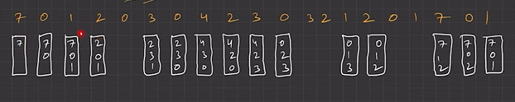
   2. 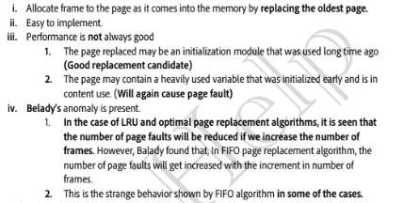
   3. 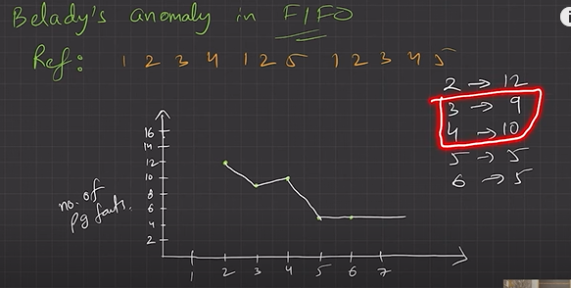
2. Optimal Page Replacement Algorithms
   1. 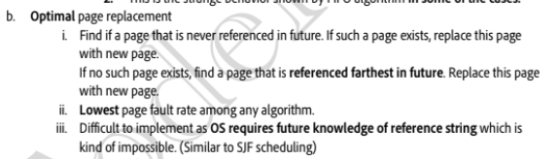
   2. This is ideal but impossible to iplememt.Similar to Shortest Job first
3. LRU – Least recently used
   1. 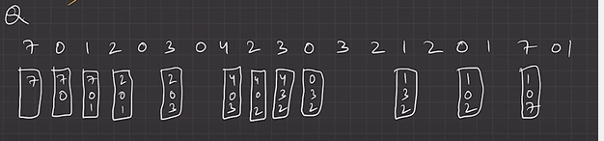
   2. 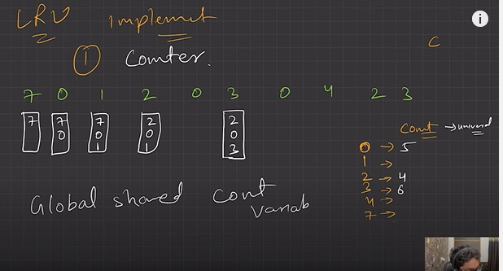
   3. 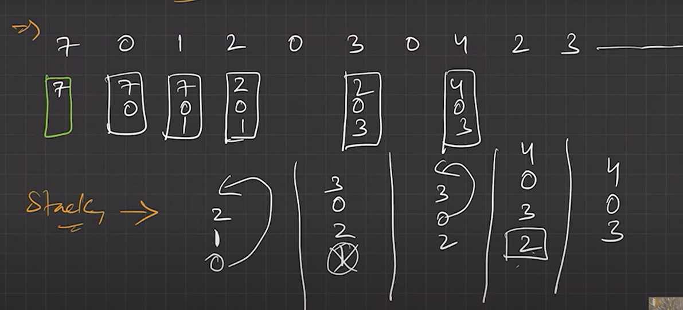

Next refer document for counting based replacement